# Introduction to Linux

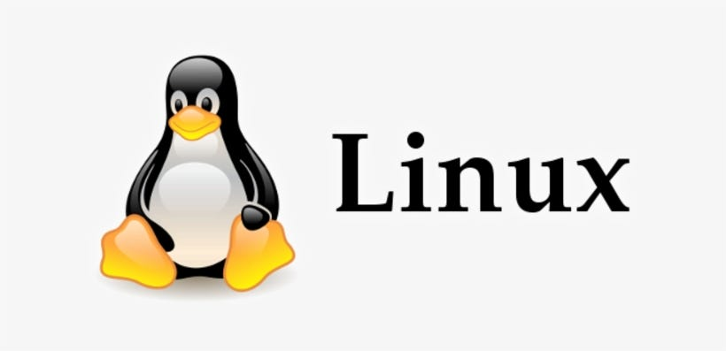

## What is Linux?

Linux is an open-source operating system that serves as the backbone of countless devices, from servers to smartphones. Developed by Linus Torvalds in 1991, Linux has since grown into a powerful and flexible OS used by millions worldwide. Unlike proprietary systems like Windows and macOS, Linux is free to use, modify, and distribute.

### Key Features:

Open-source and free

Secure and stable

Lightweight and customizable

Supports multiple distributions (distros)

## Why Use Linux?

There are several compelling reasons to switch to Linux. Whether you're a developer, a casual user, or a system administrator, Linux provides benefits that cater to diverse needs.

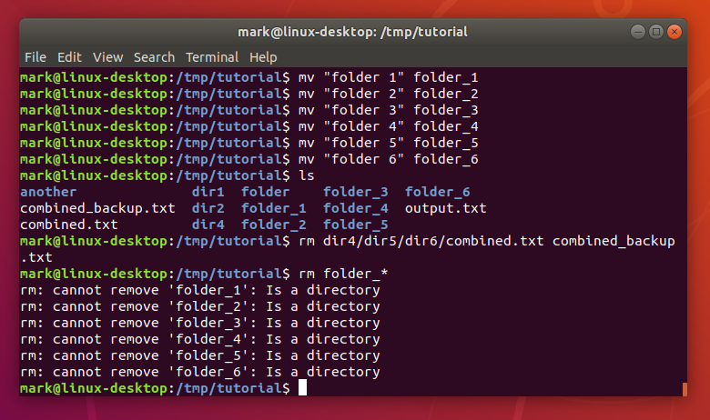

Linux is a popular operating system, particularly favored by developers, due to its security features and open-source nature. While no system is completely immune to threats, Linux is generally less vulnerable than other operating systems like Windows, Mac. Key advantages include:

Linux is known for its robust security features[1](https://www.scaler.com/topics/advantage-and-disadvantage-of-linux/" \t "/home/rocklin/Documents\\x/_blank). Its permission system gives users control over who can access and modify their files, and it supports Mandatory Access Control (MAC) for stricter access rules. The open-source nature of Linux allows developers worldwide to review the code, identify vulnerabilities, and quickly deploy security patches. Linux is also less susceptible to malware and viruses due to its architecture and the requirement for administrator authorization for program execution. Package managers ensure software is installed from trusted sources.

Linux is known for efficient resource management, making it run faster, especially on older hardware. Its stability and reliability mean it can function effectively in various situations and handle software-related failures.

Linux offers extensive customization options. Users can personalize their environment with different desktop environments, themes, and system configurations. The open-source nature allows users to modify the source code to suit their specific needs.

A vast online community provides support and solutions for Linux users. This collaborative environment helps users troubleshoot issues, find resources, and contribute to the ongoing development of the operating system. The open-source foundation fosters collaboration and accountability, ensuring that security bugs are quickly identified and fixed.

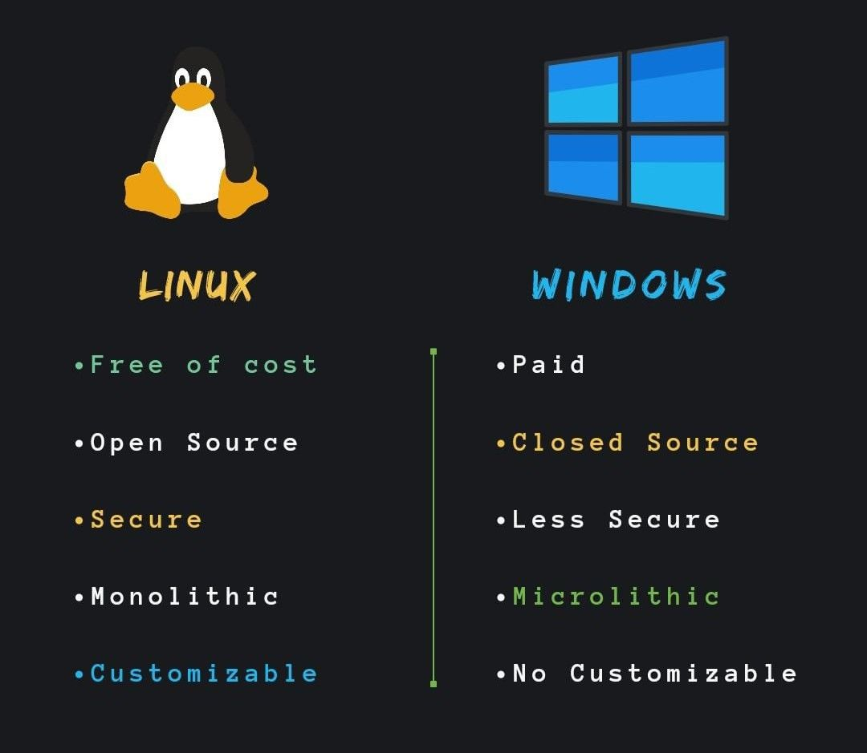

## Popular Linux Distributions

One of Linux's strengths is the availability of different distributions, each tailored for different use cases.

### Top Linux Distros:

**Ubuntu** – User-friendly and great for beginners.

**Debian** – Stable and preferred for servers.

**Centos/Rhel/Fedora** – Cutting-edge technology for developers.

**Arch Linux** – For advanced users who want full control.

# **Basic Linux Commands**

## Navigating the File System

### 1. pwd (Print Working Directory)

This command displays the current directory you are in.

$ pwd

### 2. ls (List Directory Contents)

### Lists all files and directories in the current directory.

$ ls

### 3. cd (Change Directory)

### Changes the current directory.

$ cd Documents

$ pwd

### 4. ls -l and ls -a

ls -l: Lists files with detailed information.

ls -a: Shows hidden files

### File and Directory Management

### 1. mkdir (Make Directory)

### Creates a new directory.

$ mkdir new\_folder

### 2. rmdir (Remove Directory)

### Deletes an empty directory.

$ rmdir new\_folder

### 3. rm (Remove Files and Directories)

### Deletes files or directories (with -r for recursive deletion).

$ rm file.txt

$ rm -r folder\_name

### 4. cp (Copy Files and Directories)

### Copies files or directories.

$ cp file1.txt file2.txt

$ cp -r folder1 folder2

### 5. mv (Move/Rename Files)

### Moves or renames files and directories.

$ mv old\_name.txt new\_name.txt

$ mv file.txt /home/user/Documents

### File Viewing and Editing

### 1. cat (View File Contents)

### Displays the contents of a file.

$ cat file.txt

### 2. nano (Text Editor)

### Opens a text editor.

$ nano file.txt

### 3. vim (Advanced Text Editor)

### Opens a file in Vim.

$ vim file.txt

### 4. less and more

### less: Allows scrolling through a file.

### more: Displays content one page at a time.

$ less file.txt

$ more file.txt

### System Information and Process Management

### 1. whoami (Current User)

### Displays the currently logged-in user.

$ whoami

### 2. top (View Running Processes)

### Shows a real-time view of system processes.

$ top

### 3. ps (List Processes)

### Displays currently running processes.

$ ps aux

### 4. kill (Terminate Process)

### Kills a process by its ID.

$ kill 1234

### 5. df and du (Disk Usage)

df: Shows available disk space.

du: Displays directory size.

$ df -h

$ du -sh folder\_name

.